**Project Management Concepts**

* Project vs. Operations
  + Projects = a new venture that does not yet exist
  + Operations = repeatable steps
  + Two different skill sets
* Phases of Project
  + Business Planning / Dreaming
  + Warming Up the Project
  + HOT Project = ACTION
  + Wrap Up and follow through = Closing the Project

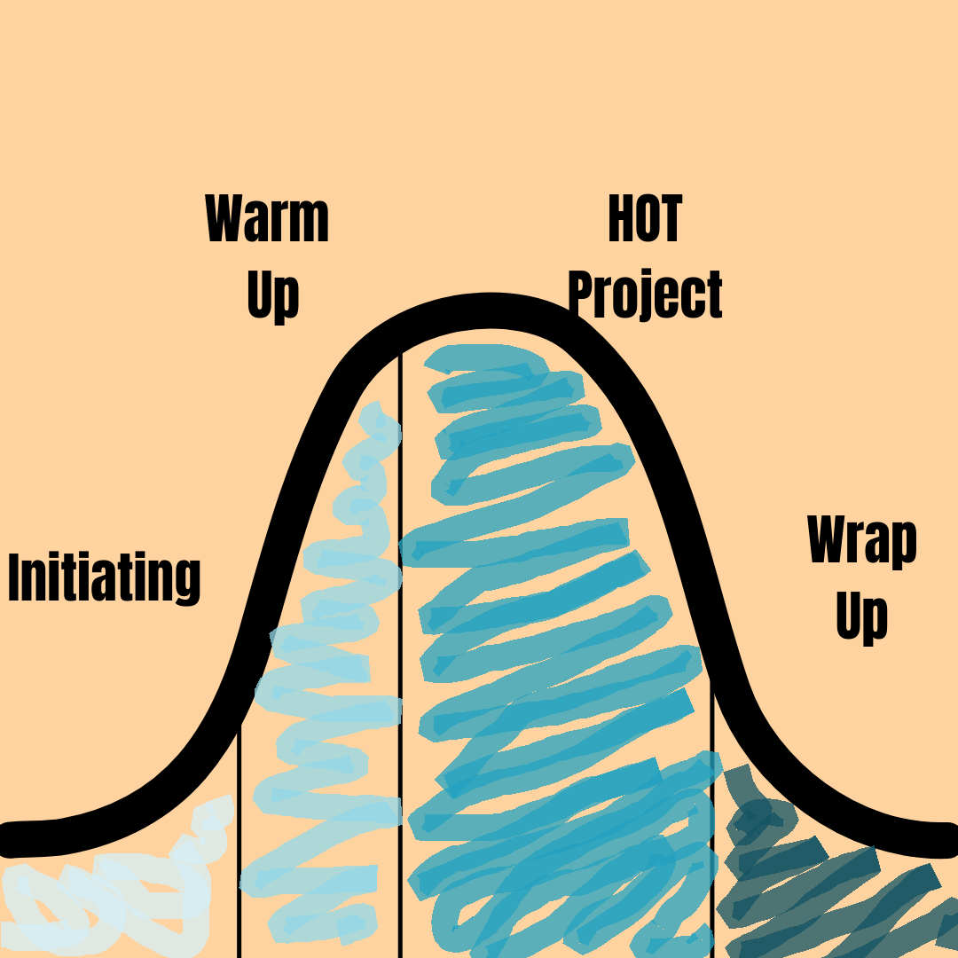

* Communication
  + The primary responsibility of the project manager – hire for this ability
  + Over communication is ideal
  + Most problems in the project will come as the result of miscommunication or the details not being as clear as you’re assuming they are
    - Keeping “Assumptions” as a part of the conversation and discussing openly what you’re assuming helps minimize miscommunications.
    - [Recommend Video: Why Can’t I Speak the Way I Do in My Mind](https://www.youtube.com/watch?v=N-Zel07vrro&t=7s)
  + Social Media: key for communicating with your most important Stakeholder: the community
  + Document Sharing Solution – Google Drive, Sharepoint, etc.
* Project Scope
  + Idea Wall Tool & Technique
  + “Scope Creep”
  + “Mission Critical” or “After Opening”
  + Continually reassess as you get closer to opening
* Rolling Wave Planning
  + Progressive Elaboration
  + Plan in detail the current phase, the next 1-4 weeks
  + Plan loosely areas of the project that are further away than that
  + As you make progress, plan the next upcoming section in more detail
* Requirements vs. Tasks –
  + **Template: Mod1_5 Task Tracking & Scheduling Dependencies**
  + “Begin with the End in Mind” – Figure out the end and work your way backwards to create the list of what needs done
  + Get specific about the vision –“Bakery” gets broken down into: fresh-baked cinnamon rolls, breads, cookies, scones, custom cake orders, cupcakes, thaw and sell items, and other custom party trays.
  + Other terms to know
    - Constraints
      * We don’t intend to upgrade the electrical so the oven will have to be below #### power threshold
    - Dependencies
      * Example: the floor can’t be stained and finished until the plumber is done cutting into the floor to lay the plumbing for the refrigeration units
    - Traceability
      * Who requested each individual requirement - if you run into time / budget issues - this is your point of contact to follow back up with for more information, to delay or eliminate the item from the project scope.
  + Requirements vs. Tasks
    - Requirement: Purchase oven for bakery
    - Tasks:
      * Discuss oven specs with grocery warehouse or other trusted source – get recommendations for both new and used equipment
      * Research used ovens
      * Get quotes on new ovens
      * Consult with electrician on electrical updates that may be needed
      * Compare used options with new quotes and decide which to purchase
      * Once decided, provide oven specs to electrician to confirm/finalize electrical updates that may be needed
      * Receive oven in store and schedule with proper contractor for installation
      * Once installed, confirm the oven is working for its intended purpose
      * Make sure appropriate personnel is trained in how to use the oven
  + Task List
    - Use ID numbers on tasks to track details, due dates, team members assigned, priority level, etc.
* Budget Management
  + Budget for Time = Timeline / Dependencies
  + Budget for Money
    - Quotes, quotes, quotes is how you build your budget and make sure it all fits together
      * Quotes give you estimates for time, money, and dependencies
        + Example: if a contractor is the cheapest, but can’t fit you in until next year, you may need to select a more expensive quote to fit your timeline requirements
      * From the quotes you can build the “Budget” and “Schedule”
* Stakeholders –
  + **Template: Mod1_4 Stakeholder Tracking**
    - Name, Phone, Email
    - Types of Stakeholders
      * Project Team
        + Contractors
        + Employees
      * Community Members
      * Abstract SH like “the community”
        + Begin the relationship with the community ASAP/as soon as you’re “Ready”

“Readiness” – the clock on the financing is ticking and this is THE MOST IMPORTANT relationship your store has, knowing how to say “I don’t know yet” will speed up your readiness.

* + - Project Role
    - Priority/Importance
* Professional & Advisory Support
  + Banker
  + Insurance Agents
  + Consultants
  + Board of Directors
  + Attorney
  + Accountant
  + Business / Personal Mentors